***Flipkart***

**Pages:**

Login / Sign up Page > Home page > Product Page > Buying options > Payment Gateway

+

1 user profile page which will be linked to the home page

**Page Structure:**

**Login Page:**

A login page that allows users to log in using mail id & password and can sign up for creating a new account.

**Home page:**

Link to Profile Page, chat history, Wishlist, coupons, logout, order history, cart, etc

**Profile page structure:**

Personal details

Chat History

Order History

Coupons

Logout

Help & Support

Search bar

Cart

Navigation for product categories

Offers

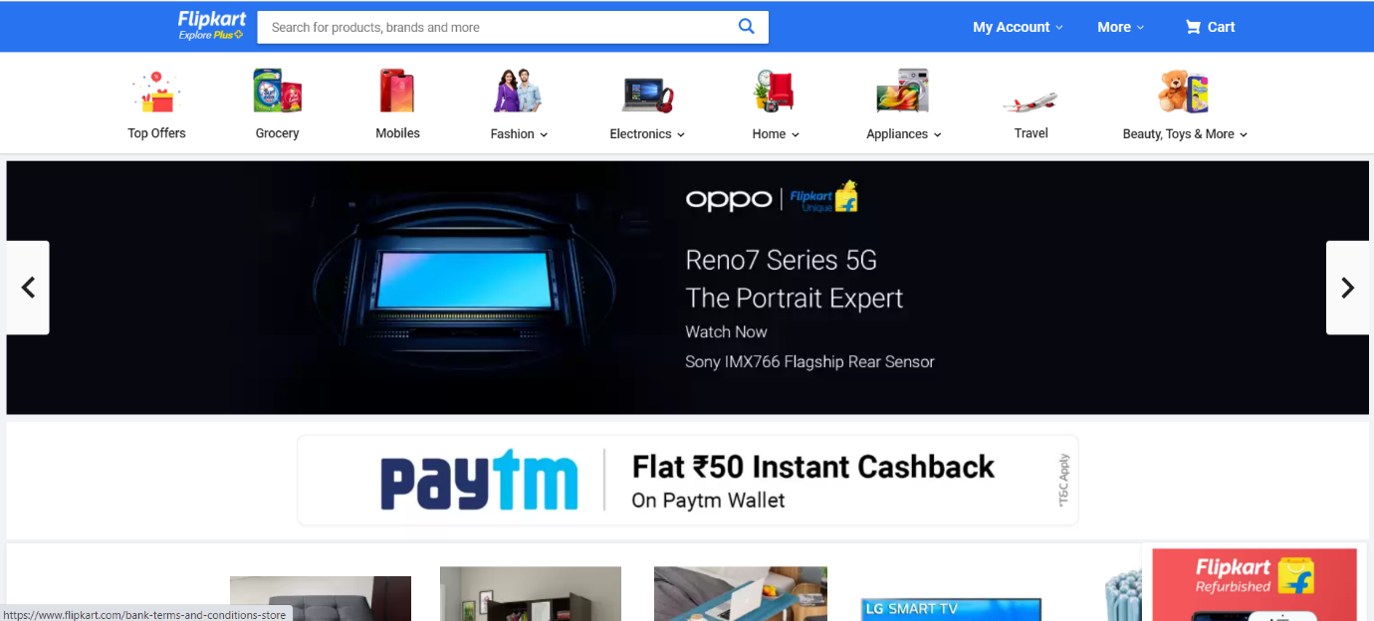

**Product page:**

Product Cards

Add to cart option

Or

Buy now

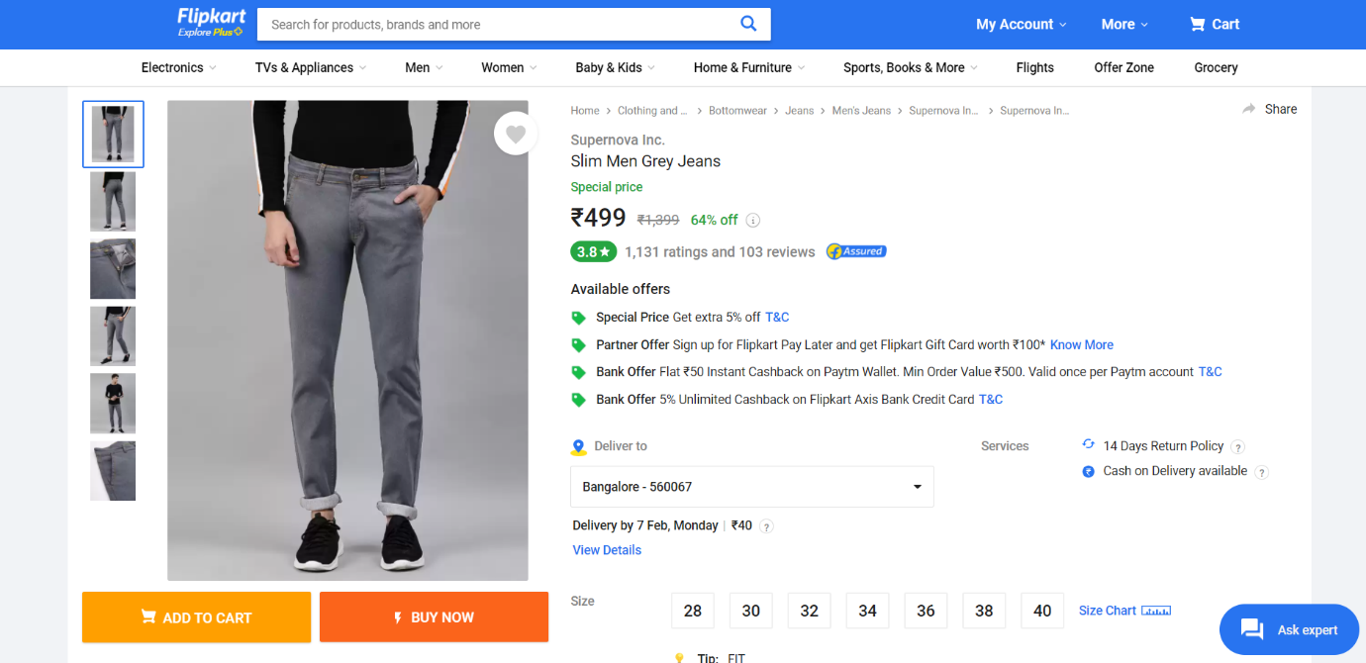

**Customer address confirmation page:**

Customers can give work addresses or residential addresses. Add new address option is also available.

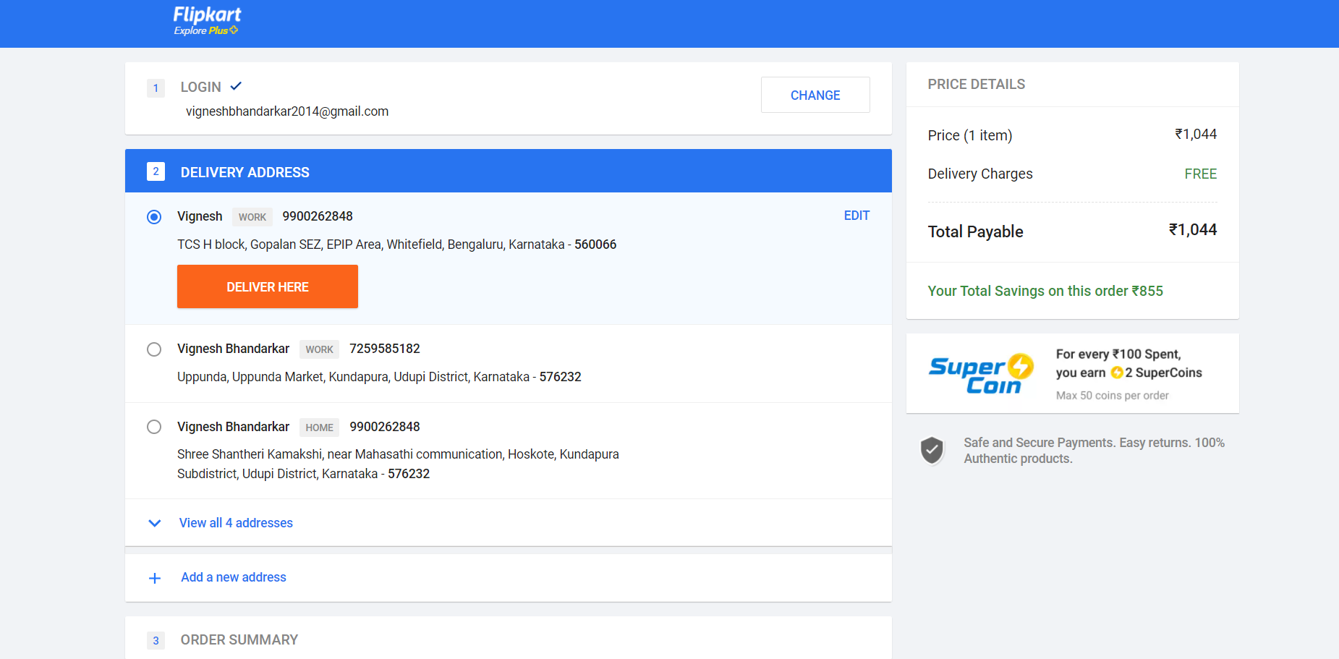

**Buying options/** **Payment method:**

COD / EMI / Debit card, Credit card, UPI, Gpay, Phonepe, and Paytm

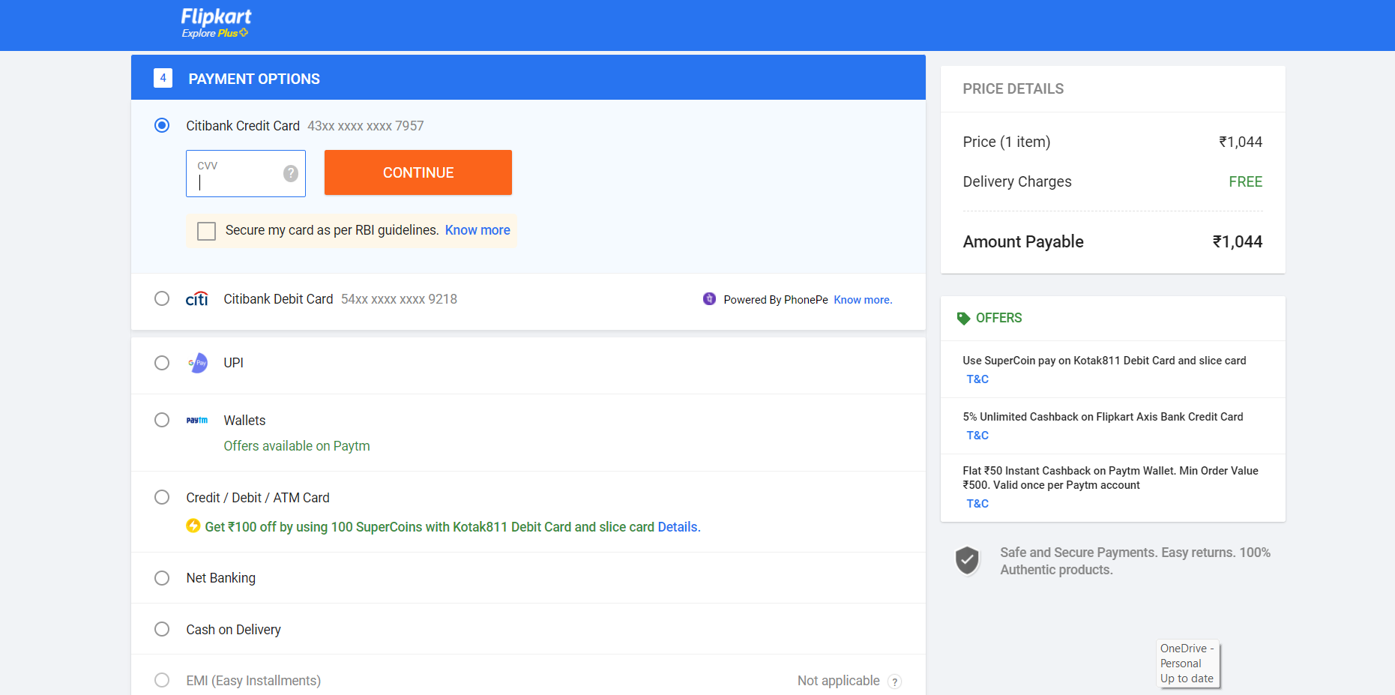

**Payment Gateway:**

**Basic Features:**

**Login page:**

Login id input(*required)

Password input(*required)

Login button

**Sign up page:**

Form --> takes personal details as input

Name

Mobile number

Mail id

Address

Sign up button

**Home page:**

Search bar to search brands or by product name

Filters

Horizontally aligned card structure

Link to the profile/account page

All the personal details entered during signing up

+

Option to edit them

**Items in cart:**

Shows products added to cart + option to edit them(delete any)

**Product Page and Filters:**

The product page consists of different variety of products based on data collected.